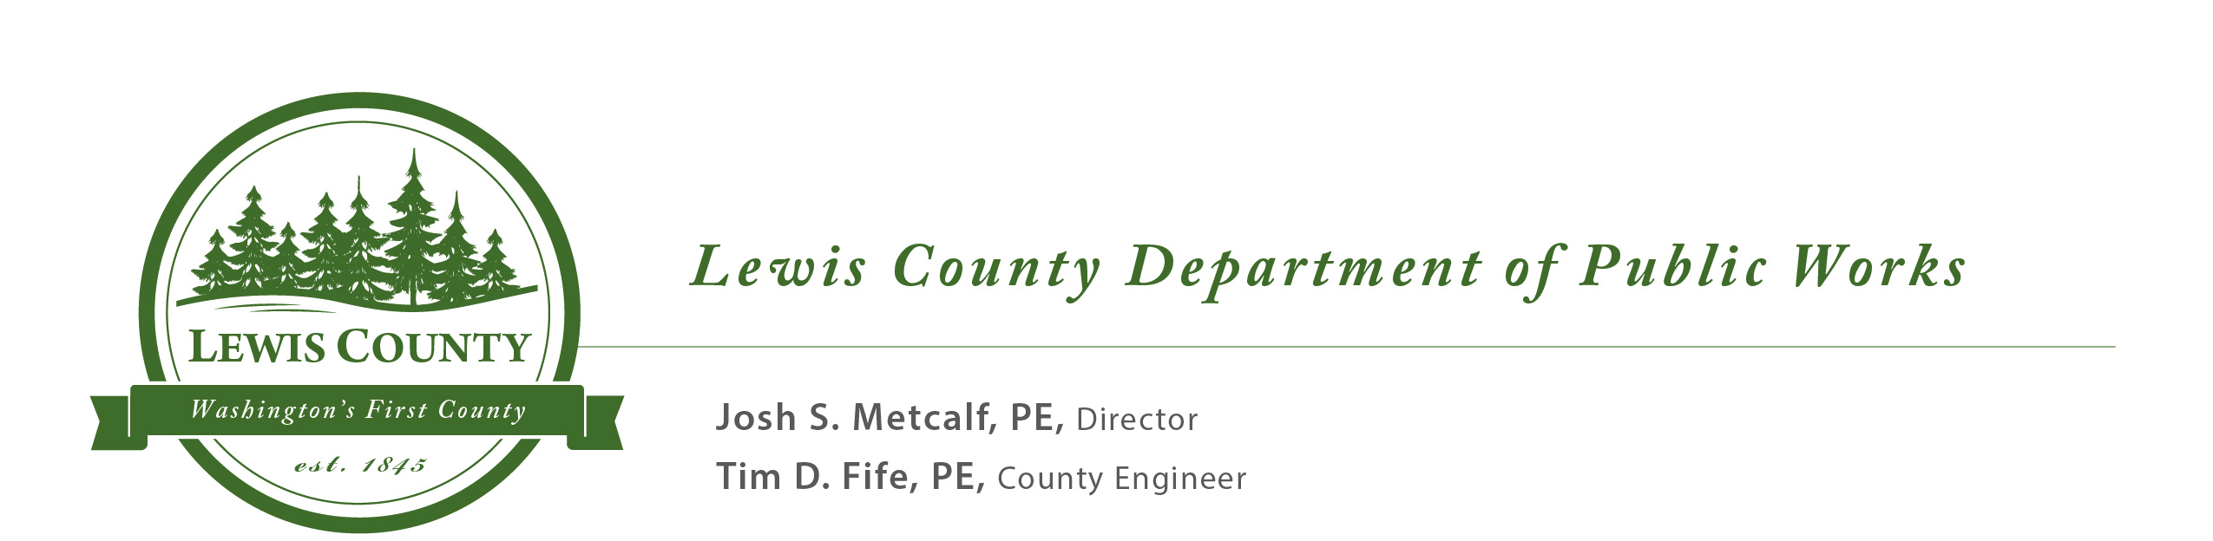

2020 LEWIS COUNTY SMALL WORKS ROSTER APPLICATION
When Public Works receives your completed, signed application and a copy of your current WA State business license (with
UBI #), you will be placed on Lewis County’s Small Works Roster in each of the categories you selected. The application and the roster are available on the Lewis County web site (http://lewiscountywa.gov/publicworks/contracting-consultants-rosters-bids /). If you have any questions, contact Rose Williams at (360) 740-2671 or email – rose.williams@lewiscountywa.gov

Return completed application to: Lewis County Public Works CHECKLIST:
Attn: Small Works Roster ____ Sign application

2025 NE Kresky Ave. ____ Enclose WA Master
Chehalis, WA 98532 Business license (UBI#)
(PLEASE TYPE OR PRINT) ____ Check category(ies)

______________
(Company Name) (Contact Person)

(Address) (City) (State) (Zip)
_ ______________________
(Phone) (Fax) (Cell) (Contractor #)
Internet: No Yes ___________________________________________
(E-mail Address) (Signature)
Is your firm a qualified Disadvantaged Business Enterprise? Yes ________ No __________
The following are the current Small Works Roster categories. To request a new category, contact Public Works. The above listed company wishes to be placed on Lewis County’s Small Works Roster and contacted for work under the following categories for which we are BONDED, LICENSED, and INSURED (where required by law):

Aerial Photography
Asbestos Removal and Mold Remediation
Asphalt Concrete Paving
Auction Services
Backflow Systems
Blasting / Drilling and Blasting (Rock)
Boat and Operator for maintenance on rivers
Bridge Maintenance
BST Surfacing
Cast-in-Place Concrete
Communications Systems
Concrete Cutting and Coring
Construction Materials
Debris Removal
Demolition
Drywall
Dust Control
Electrical Services
Environmental Protection
Excavating, Grading & Road Construction
Facilities-Maintenance and Services
Fencing
Fiber Optics & Data Cabling
Fire Alarm Systems – Installation & Monitoring
Flooring
General Contractor (Buildings)
GIS Geodatabase
Guardrail Repair & Installation
Gutters/Rain Gutters
Hauling and Trucking
Hazardous Materials Disposal Site
Hazardous Materials Response
Heating & Air Cond., Controls, & Duct Cleaning
Industrial Vacuuming Services
Landscape Services
Lead-based Paint Removal
LIDAR Terrain Mapping
Masonry
Materials Testing
Moving and Storage
Painting
Pest/Wildlife Control & Trapping
Plumbing
Project Estimating Services
Pumps: Service, Test & Install
Real Estate Appraisal Service
Rip Rap Placement and Flood Control
Road Striping and/or Pavement Markings
Rock Crushing
Roofing
Security Services
Septic Systems
Snow & Ice Control
Sprinkler Systems
Solid Waste Maintenance and Services
Technology
Timber Cruisers
Traffic Control and Devices
Tree Felling & Removal
Tub Grinding and Chipping
Underground Storage Tank Services
Underground Utilities, Box Culverts, & Culverts
Water Testing/Water Systems
Welding-Specialty
Well Drilling

